Emailing Purchase Orders- Vendor File

When printing a purchase order, the Advantzware Software has an option to OUTPUT to EMAIl.  
This will convert our business forms created with the XPRINT software into a .PDF format that can be read from any computer that hour customer may own. However, you can save much more time by having the EMAIL automatically import the contacts to the SEND TO section of the email.

The Vendor File allows unlimited contacts via the PHONE ICON. Each contact may have unlimited notes via the Fountain Pen Icon. Each contact will have a title, phone number and email address.

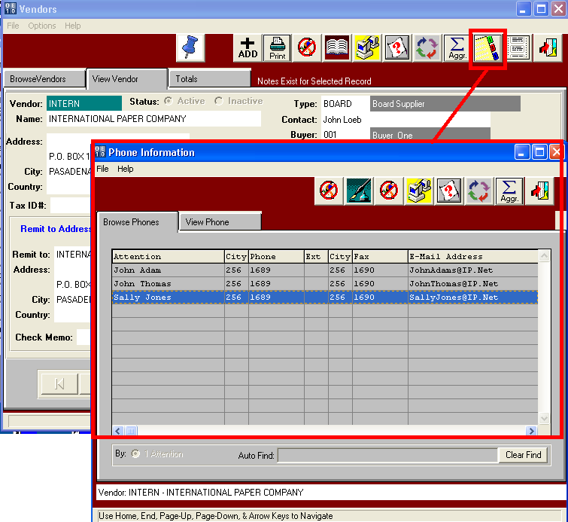

Emailing Purchase Orders – Phone Icon

Each contact can be setup for automatic emailing by clicking the E-MAIL NOTIFICATION toggle box.  
Once this is checked, then the business forms or reports can be checked that this person should receive.  
For example, below the program to print the purchase order is checked with the word YES. When printing and email, the user must click the OUTPUT TO: EMAIL option. Once check, the Advantzware software will generate a Purchase Order Form via the XPRINT software and simultaneously convert this business form into a .PDF format as an attachment to the email. The SEND TO: section of the email will then simultaneously import the contacts from the Vendor PHONE Icon. No matter, who emails the purchase order within your company, the proper contacts will be sent the email. Please note, this does not require the name to be setup in anyone’s Address Book in Microsoft Outlook. Each contact must be setup in the same manner .

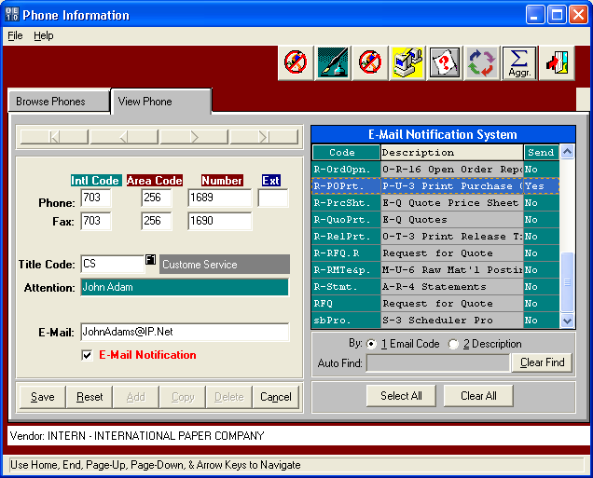

Emailing Purchase Orders - ECODES

The Ecode files is an alternative method to setting up automatic contacts for emailing compared to the vendor file. This provides the ability to quickly define many companies at one time, whereas the Vendor File is on vendor and one contact at a time. Each contact must still be defined in the Vendor file with a title code and email address. At the top of the Main Menu, click the Codes button, then click the Email Codes Menu Option.

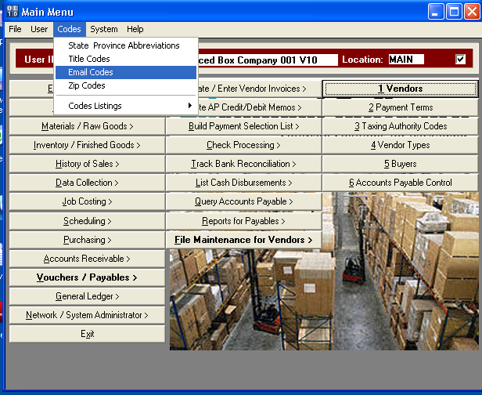

Emailing Purchase Orders - ECODES

The ECODES program will be listed showing the Advantzware Menu keys that are used to generate the contact list to be emailed. Below the purchase order program has been selected so that contacts by company can be assigned.

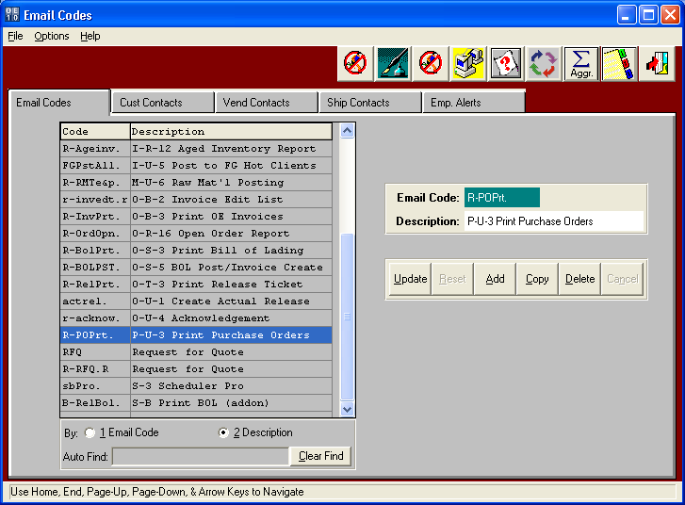

Emailing Purchase Orders - ECODES

Click the VENDOR CONTACTS folder to select contacts for emailing a purchase order.  
The TOP window shows the contacts that have already been defined and are all set.  
The BOTTOM window is the entire list of all the contacts defined in the Advantzware phone icon.  
The Vendor File was used to defined Sally Jones, John Adams and John Thomas for International Paper.  
Alternatively, we could sort the Advantzware contacts by Company, Vendor, Title or Contact.  
For example, I have listed all names for INTERN and then clicked the Select ALL button on the bottom right, then click ADD to transfer the selected names to the TOP WINDOW as our default contacts to email to International Paper. Alternatively, we could sort by title and this would list all vendor contacts. We could then select all and click ADD to transfer the entire range on contacts to the TOP window.

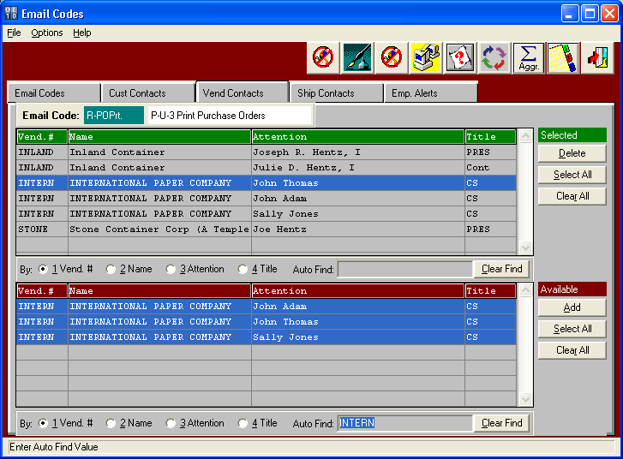

Emailing Purchase Orders – Printing

When printing and email, the user must click the OUTPUT TO: EMAIL option. Once check, the Advantzware software will generate a Purchase Order Form via the XPRINT software and simultaneously convert this business form into a .PDF format as an attachment to the email. The SEND TO: section of the email will then simultaneously import the contacts from the Vendor PHONE Icon. No matter, who emails the purchase order within your company, the proper contacts will be sent the email. Please note, this does not require the name to be setup in anyone’s Address Book in Microsoft Outlook.

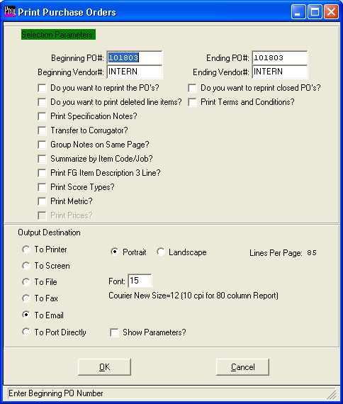

.

Emailing Purchase Orders - Printing

The Net Result to Setting up the contacts, is the names will appear on the SEND TO:   
section of the email. As you can see the purchase order form is converted to a .PDF format that can easily be read by any computer.

